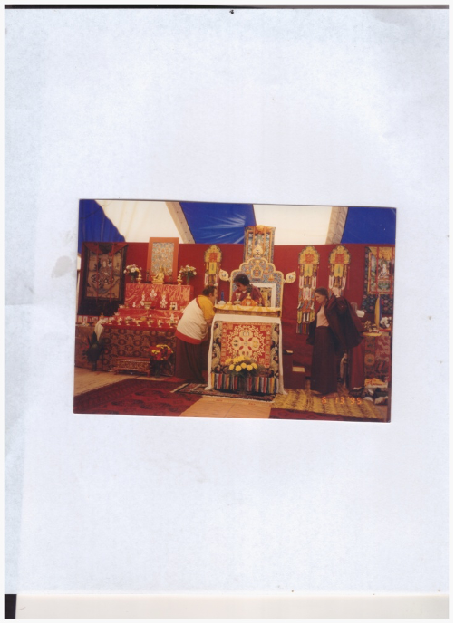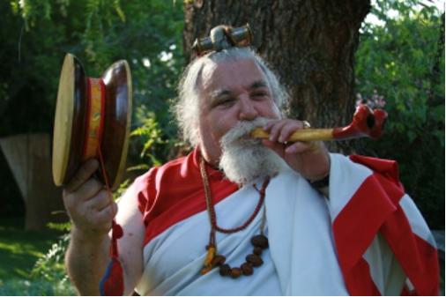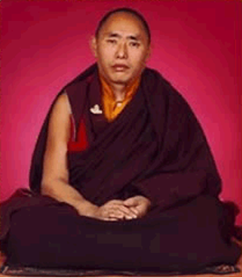

Lyr lama ari bodh rinpoche

In Dzogchen, trekchö (khregs chod) ***means*** "(spontaneous) cutting of tension" or "cutting through solidity." The practice of trekchö reflects the earliest ...

Scan TNR

​​​​<https://www.youtube.com/watch?v=ZCQ5RFC9jG8>

Longchenpa - A Meditation on Four Methods of Resting - Dzogchen

<https://www.youtube.com/watch?v=QTHe_NWUblc&ab_channel=TalksatGoogle>

relaxation vis-a-vis laziness

3 kinds of laziness

1. gross

2. putting off laziness

subtle-

3. who want to do other things great subtle (hidden-

UPADESHA I

Distilling The Quintessential Nectar Of Rigpa - Meeting The Lama’s Mind In Non Dual Union

Tashi Deleks. May all beings become happy and enlightened!

This concise upadesha is a simple yet profound guide for vajrayana practitioners when they are preparing to receive dharma teachings, oral transmission (tib. lung) and empowerments (tib. wang), whether one-on-one with a qualified lama or in a public dharma teaching environment. This upadesha is preeminently useful for one’s daily sadhana practice and is a propaedeutic for deeper experiential understanding in a retreat setting, where direct guidance from the gomchen awakens the dharma practitioner's view and meditative siddhis. This is the profound, simple way of the gomchen (great meditator). In the Dzogchen tradition it is said yoginis and yogis are very intelligent and very lazy. This means they streamline the path by utilizing pith instructions regarding view, meditation and conduct. Their seeming laziness is intelligence, cutting through the apparent solidity of the ground and the spontaneous cutting of tension (trekchod) which avoids lengthy “profundities.” Karma Chagme states it in *Union of Mahamudra and Dzogchen* thusly:

“You may know a lot, but if you don’t put it into practice, it’s like dying of thirst on the bank of a great lake. Likewise, it sometimes happens that a common corpse is found in the bed of a great scholar.”

The title of this upadesa refers to:

1. Meanings of distilling, quintessential, nectar, rigpa

The derivation of the word is from the Latin verb *“distillare”* meaning “to drip down.” In ancient alchemy, a downward slanted tube cooled and condensed vapors from heating an herbal or other preparation. The Tibetan practice of chulen, or “extracting the essence” combines rasayana and a variety of postures, mantras, and meditative techniques to derive the sublimest quintessential (literally the 5th distillation) nectar (skt. amrita, immortal/deathless) of rigpa (Tibetan for intrinsic awareness), that is, knowledge of the ground of reality (tib. zhi).

2. Meaning of Meeting the Lama’s Mind in Non-dual Union

At that moment the practitioner is, as the Omniscient Longchenpa states, realizing both primordial purity (tib. khadag) and spontaneous presence (tib. lhundrub), and if this vajra-like samadhi is continuously realized (or distilled), one becomes a knowledge holder (tib. rigdzin). When receiving teachings, lungs, or wangs, to the degree the practitioner has accomplished this quintessential distillation of rigpa, she/he/they will naturally enter this state and meet the lama’s mind in non-dual union. Don’t miss this: giving katas, money, or gifts to the lama has merit, but dynamically engaging the lama’s mind is the quintessence of respect for the Guru and the quickest method of awakening our meditation siddhis and both absolute and relative bodhicitta. If practiced properly, we will never again need to engage in “chasing the musk deer.”

This practice is an active process on the part of the student.

It is vitally important that you, the attending dharma student, prepare in advance to receive a dharma teaching, oral transmission, or empowerment by purifying your three gates of body, speech and mind. For example, by reciting vajra recitation, the three purifying syllables, OM AH HUNG. If time permits, one may utilize a meditation with support to remove gross and subtle toxins created by the three poisons of ignorance, desire and hatred (e.g. lung jon, the small vase breathing technique). This process brings the purified winds (tib. lung) into one’s central channel, causing one to become calm and relaxed. It is through that calm, relaxed openness that the experience can be allowed to deepen. Deep relaxation is a golden key which will unlock your treasure mind, which is of course rigpa or sublime intrinsic awareness.

The student must realize the inseparability of their own intrinsic awareness and the lama’s sublime mind, which is also intrinsic awareness. One can liken this relationship to a yogic mind-sport. As my sublime, dear root Dzogchen master, H.H. Dungse Thinley Norbu Rinpoche says of this state: our Play Mind is fully activated (read Magic Dance for more). When many yoginis and yogis engage in this mind sport or Play Mind en masse, the Buddhas of the ten directions and three times shower sublime blessings throughout the myriad world systems for the benefit of all sentient beings. The degree to which a practitioner creates the environmental continuum required for the quintessential distillation of rigpa to occur directly depends upon the extent to which they are dynamically resting in the natural state. This is because the meditational relationship of student and teacher is non-dual.

The five elements of one’s gross and subtle bodies (earth, fire, wind, water and space) are in a state of equipoise, vibrating with the outer five elements of the phenomenal world. This state of equipoise and vibration is a primordially pure, inseparable unity. For those practitioners who wish to follow the profound path of the ngakpa/ngakmo, this inseparable unity of the secret, inner and outer five elemental energies creates the ground for manifesting to benefit beings (e.g. weather modification and dur healing ceremonies).  
 After the practitioner is “relaxing in the natural state,” they begin the so-called ordinary preliminaries of the four contemplations that turn one's mind to dharma. H.H. Dudjom Rinpoche, agreeing with the great Drikungpa, emphasizes the four contemplations, acknowledging that although other lamas emphasize the extraordinary ngondro practices, the ordinary preliminary practices of the four contemplations are necessary to turn one’s mind to dharma and turning one’s mind to the dharma is necessary for the beginning of a truly meaningful dharma practice and also to receive teaching and transmissions. After one’s mind has been turned towards the dharma, one can then deeply appreciate the rare causes and conditions for a precious human birth: healthy mental and physical faculties, the kindness of our mother and father (or other caregiver), both in caring for our physical needs and acculturating us both morally and spiritually, to be born and raised in a land where the sublime dharma is taught by qualified teachers, and to have the leisure time to receive and practice the rare jewel of the buddha dharma. One appreciates this while knowing all phenomena are transient and have no permanency and our death is always at hand. From birth to old age, our lives are subject to constant mental and physical suffering. E ma ho! When we realize there is a path to the cessation of suffering available to us, culminating in the realization of the true nature of mind, samyak sambuddha, that is, total complete enlightenment. Realizing this, we begin to see our dharma practice and reception of Buddha's teachings via transmissions from sublime masters as truly wish fulfilling jewels.   
 We can invoke the power of the three jewels of the buddha, dharma, and sangha and generate bodhicitta, the enlightened mind, for the benefit of all sentient beings. If one is a dzogchen or mahamudra practitioner, one utilizes the view (tib. tawa), meditation (tib. gom) and action/conduct (tib. chopa) as one’s methodology. The view is to see the non-substantial nature of one’s mind and all phenomena, which are inseparable from vast openness (tib. longchen) and its spontaneously arising (tib. lhundrup) dynamic activity manifesting as luminous clarity (tib. osel) and great bliss (tib. dechen). This is the vast openness, also called many other names such as dharmata (Sanskrit for *the space of reality*) or tathagatagarbha, which in Sanskrit means *womb of the Buddha*.   
 Tathagatagarbha's womb analogy for the space of reality which is also the intrinsic awareness of our own heart-minds aptly suggests that vast openness is a very natural resting place after incarnating into the womb. The white seed of our father and the red seed of our mother unify, forming pink bodhicitta. For sentient beings, who have little to no awareness in the bardo, it is this moment of pink bodhichitta that they can first relax since their bardo ordeal began. After our incredible, earthshaking arrival into our mother’s womb from the akash[1], pink bodhichitta rests comfortably on a blue lotus… That pink bodhichitta is rigpa, our vajra-like awareness, so at this point we are definitely resting in the natural state! For ordinary people, this first time after incarnating in our mother’s womb that we are able to realize our natural state is a portend for our future ability to realize the true nature of mind and continue this profound, deep resting.

H.H. Tenzin Gyatso, the 14th Dalai Lama, likens the profound, deep resting of the natural state to a person going through a vigorous physical training regimen ending in she or he totally letting go of rigid mental and muscular control… in modern parlance, the person ‘vegges out’ (but with dynamic lucidity). Each moment is a wonderful opportunity to implement the dzogchen view, meditation and conduct. The practitioner can also use this method in dream yoga.

The journey of womb entrance is not consciously undergone by sentient beings (regardless of the type of coming incarnation, human or other types). Maintaining primordial awareness in the intermediate states, the womb, during birth, and finally, while exploding out into a nirmanakaya realm such as our Jambudvipa - with a healthy body and critical awareness - is what Buddhas and Bodhisattvas do. They can accomplish this to varying degrees based on their stage of the path (skt. bhumi) because they are resting in primordial, intrinsic awareness without pause. Remember this as you begin your voyage of what my most sublime dzogchen master, H.H. Dungse Thinley Norbu Rinpoche, calls the white sail’s crossing to the further shore.Thus:

OM GATE GATE PARAGATE PARASAMGATE BODHI SWAHA:

*Gone, Gone, Gone Beyond, Gone Utterly Beyond - Oh, What An Awakening!*

*Gone, Gone, Gone Beyond, Gone Utterly Beyond - Oh, What An Awakening!*

*Gone, Gone, Gone Beyond, Gone Utterly Beyond - Oh, What An Awakening!*

Having contemplated this, as you receive teachings, you should practice distilling the quintessential nectar of rigpa: meeting the lama’s mind in non-dual union. We conclude our receiving of transmissions, teachings, and/or practice by dedicating the merit we have accumulated for the benefit of all sentient beings.

*Sarvam Mangalam!*

1. Tib. namkha (sky)